**PROBLEM STATEMENT**

The aim of this research is to utilize a computer vision model to determine the population residing in the floodplains of Patna affected by potential flooding of the Ganga River.

**INTRODUCTION**

The Ganga is a major, holy river in the Indian subcontinent that rises in the Himalaya mountains and flows approximately 2,525 kilometres eastward, through an expansive plain, into the Bay of Bengal. It mainly flows through five Indian states: Uttarakhand, Uttar Pradesh, Bihar, Jharkhand, and West Bengal. It has a catchment area of 861,404 km2, or 26.4% of India.

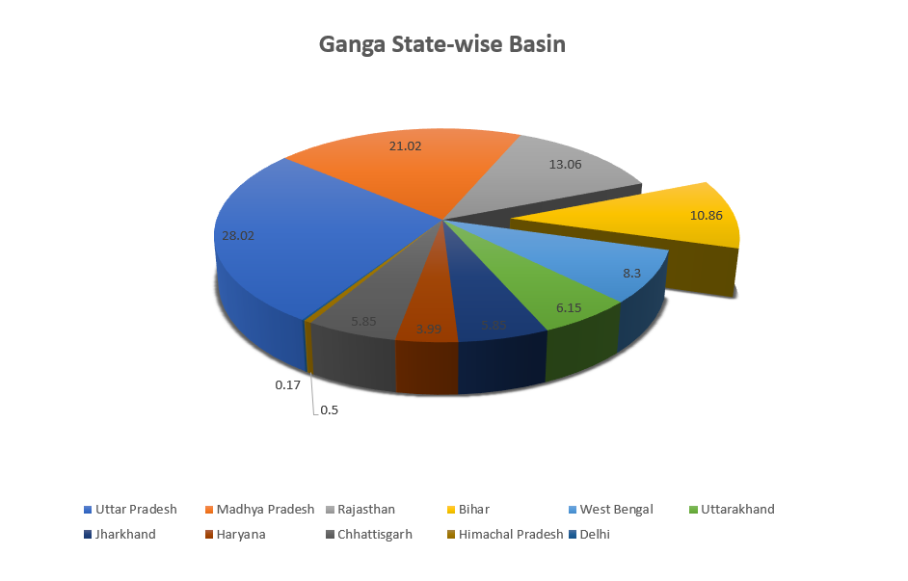

Fig 1. Percentage distribution of flow of River Ganga through different states in India

Patna, the capital city of Bihar, is one of the sites where the river flows prominently, making it an important part of the city's environment and daily life. This city's history dates back more than 2500 years; Patna’s ancient name was Pataliputra, and it served as Magadha's capital for several thousand years under various dynasties.

Patna is situated on a level strip of ground on the Ganga River's south bank, which slopes to the south and east. Furthermore, it is bordered by the Ganga in the north, the Punpun in the west, and the Sone in the east. The Ganga River, with its cultural, religious, and historic importance, is an integral element of Patna's character, attracting both residents and visitors. The river's importance goes beyond its physical presence, influencing the city's traditions festivals, and daily life.

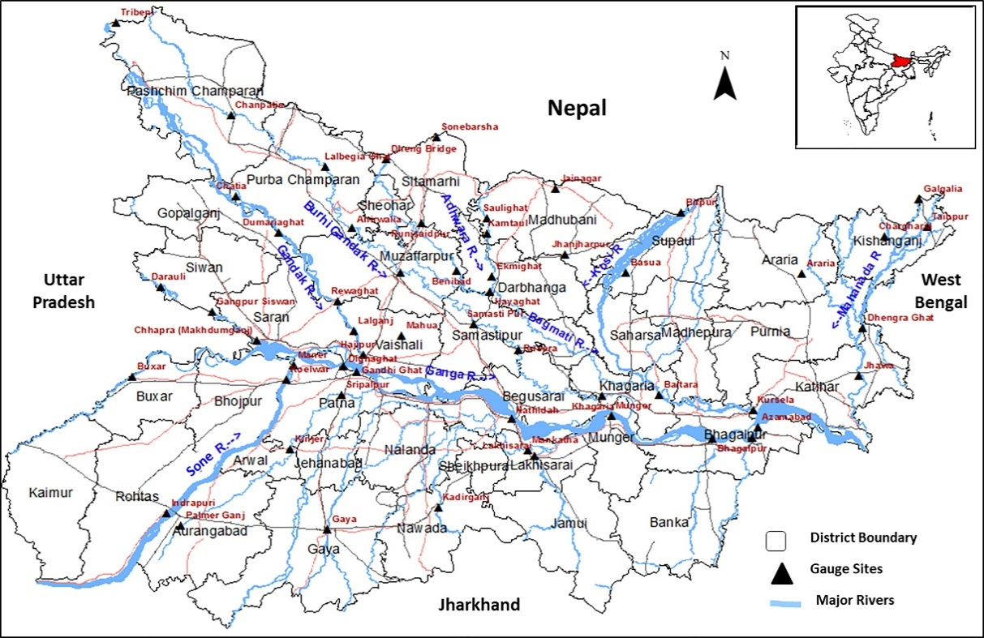

Fig. 2 Location map of the state of Bihar (Bhatt et al., 2021)

**DEMOGRAPHICS OF PATNA**

**Population**

Patna, like many other cities, is home to a diverse population with people from various backgrounds, cultures, and communities. Patna's population is made up of people from various regions of India, as well as different religious, linguistic, and ethnic groups. Patna is primarily an urban centre, but it is surrounded by rural areas; the city itself has a mix of residential, commercial, and industrial zones. The rural areas are often involved in agriculture, and have a more traditional way of life. The population of Patna has increased by 20.88% in the last 10 years from approximately 2,633,000 in 2014 to approximately 2,514,590 in 2023.

Fig. 3 Graph showing the increase of population in Patna

**Housing**

Patna has a wide variety of housing options, including traditional houses, modern apartments, and gated communities. The number of houses in Patna increased by 15.24% from 363,667 houses in 2014 to 419,098 houses in 2023. The Patna urban area has an average household size of six members. The population density has increased by 26.55% from 1,823/km in 2011 to 2,307/km in 2023.

**Rainfall**

Patna experiences a humid subtropical climate, characterized by hot summers, a monsoon season with heavy rainfall, and relatively cool winters. The region follows a typical seasonal pattern with three main seasons: summer, monsoon, and winter. The monsoon season in Patna begins in June and lasts until September; this period sees the majority of the annual rainfall, with heavy rains occurring during July and August.

Fig. 4 Graph showing the history of rainfall in Patna

The southwest monsoon brings moisture-laden winds from the Bay of Bengal, resulting in widespread rainfall across the region, which heavily influences the annual rainfall of Patna. The city receives a substantial amount of rainfall during the monsoon season, with an average annual precipitation of around 1,020 mm.

**Floods**

The topography of Patna is saucer-shaped, making it difficult to flush out water. The city has a gentle slope from north to south, and is impacted by rising waters in the Ganga, Punpun, and Sone rivers.

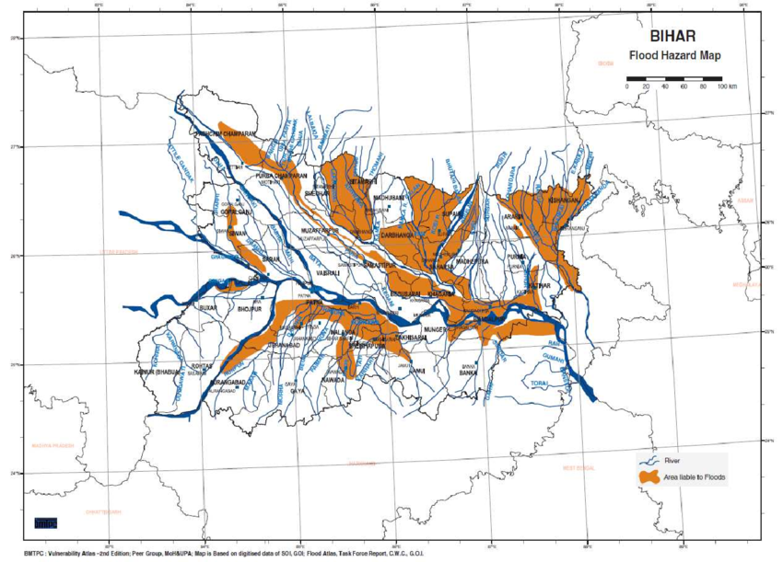

Fig. 5 Flood hazard map of Patna (encircled) (Diwakar et al., 2016)

The Ganga River is prone to flooding during the monsoon season, and Patna, being situated along the banks of the river, has faced flooding incidents in the past. Floods in the Ganga are often caused by heavy rainfall in the upstream areas, leading to increased water flow downstream, causing property loss, structural damage, and the spread of waterborne diseases.

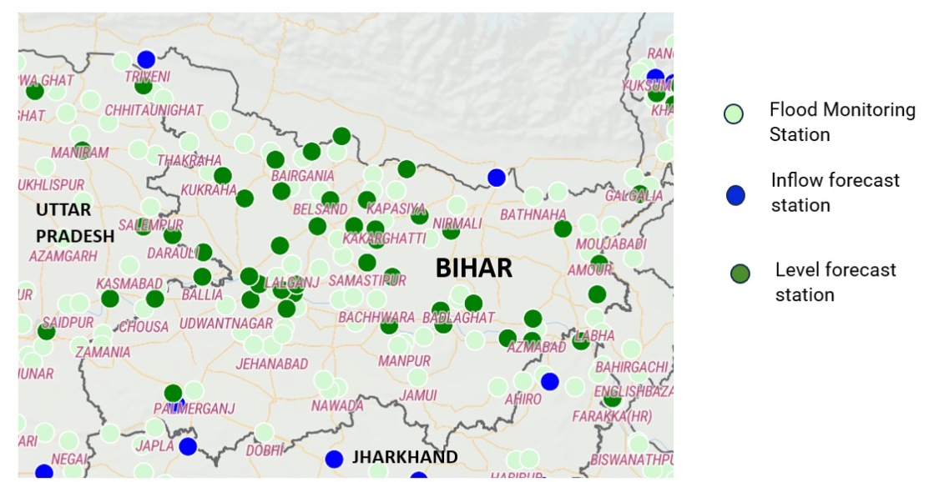

Fig. 6 Locations of CWC flood forecasting stations in Bihar (CWC, 2024)

In September 2019, due to unusually above-average rainfall, Patna experienced heavy flooding of the Ganga River, with nearly 177 mm of precipitation within 48 hours. This was a stark contrast to the amount of rainfall received in the past decade, with an average of 10 mm of precipitation per month.

Fig. 7 Graphs showing the destruction caused by flooding of the Ganga River in Patna

**Elevation of Ganga floodplain**

Floodplains are designed to receive excess water during periods of heavy rainfall or snowmelt. This periodic flooding is a natural and essential process that helps distribute nutrients, maintain soil fertility, and shape the landscape. Natural floodplains act as buffers during floods, absorbing and slowing down floodwaters, reducing the peak flow downstream. However, when floodplains are extensively developed, these natural functions may be compromised, leading to increased flood risks.

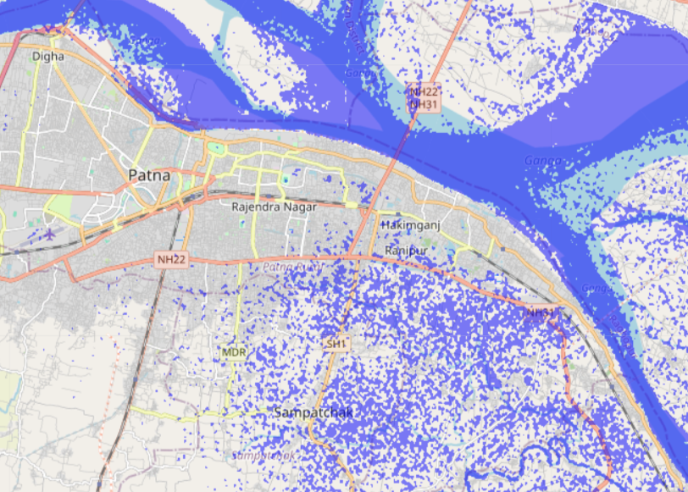

Fig. 8 Map showing the elevation of floodplains (blue) around Ganga in Patna

The geography of Patna is characterized by the Gangetic plain, which is a vast and fertile alluvial plain formed by the deposition of sediments carried by the Ganga and other rivers over time. The elevation of the floodplain in Patna is generally low, and the region is susceptible to flooding during the monsoon season. The Ganga River plays a crucial role in the hydrology of the region, and periodic flooding is a natural occurrence in the floodplain.

**Drainage system**

The drainage system in Patna includes a network of stormwater drains and canals designed to manage rainfall and prevent waterlogging during the monsoon season. The city faces challenges related to flooding and waterlogging due to its low-lying topography and the periodic rise of the Ganga during the monsoon. The city has a system of stormwater drains that are intended to carry rainwater away from streets and neighbourhoods, preventing waterlogging.

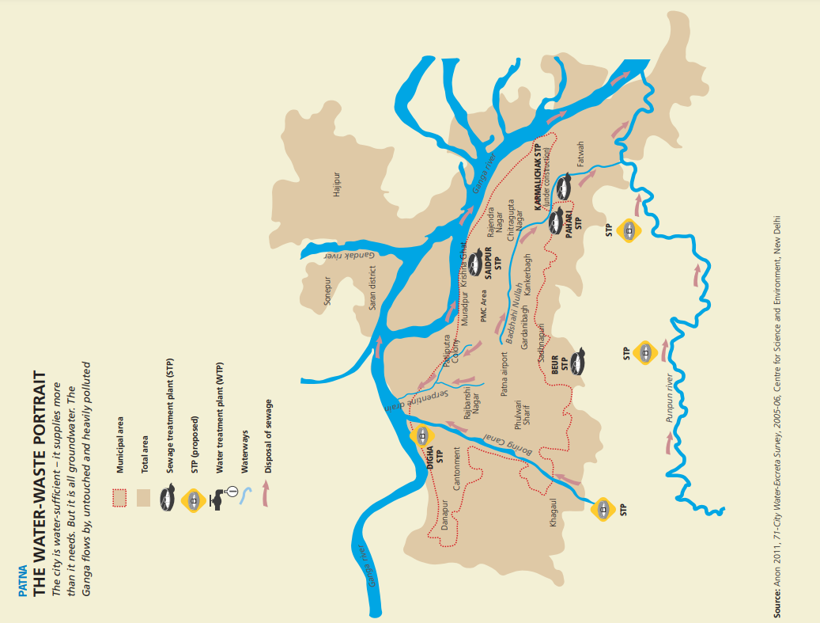

Fig. 9 Drainage system in Patna (CSE, 2011)

Surprisingly, Patna has not established a new main drainage network since 1968, with the exception of a few drains built in newly developed residential areas. In March 2023, work began on a new stormwater outfall facility in Patna and surrounding areas to alleviate flooding and waterlogging. The project sought to build 103 drain lines, divided into nine packages, for a total of 185 kilometres of drainage network.

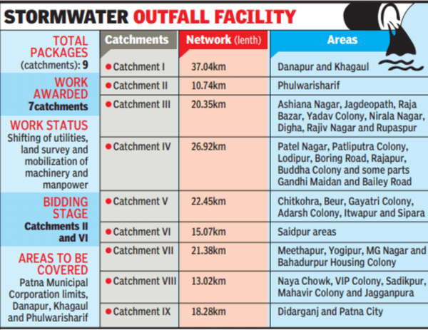

Fig. 10 Information about the new stormwater construction (TOI, 2023)

Presently, there are 9 big, 14 medium and 172 small drains in Patna. There are a total of 38 sump houses that are functional in the city, while there are no pumping stations in areas like Kankarbagh, Khagaul, Danapur and Phulwarisharif. The proposed drainage plan will cover 130 km2 of area in and around the city, including Danapur, Gola Road, Khagaul and Phulwarisharif.

**Water pollution**

Presently, the Ganga riverbanks are home to more than 29 cities, 70 towns, and numerous villages, collectively discharging over 1.3 billion litres of sewage daily into the river. The pollution of the Ganga in Patna is attributed to various factors, including industrial discharge, untreated sewage, agricultural runoff, and other anthropogenic activities. The discharge of untreated sewage into the Ganga is a major contributor to water pollution. Urban areas, including Patna, often release untreated or partially treated sewage into the river, leading to high levels of biological and chemical contaminants. People's habitual use of Ganga water for a variety of purposes increases the risk of human health complications.

Alam et al. (2023) conducted a study to assess the water quality of the Ganga River at various Ghats (stairs or a passage leading down to a river) in the Patna urban region, ranging from Digha Ghat to Gai Ghat. Water samples were collected from 15 separate ghats; the results showed that all of the Ghats were deemed unsafe for drinking purposes, and it was advised that water be made available only after extensive treatment.

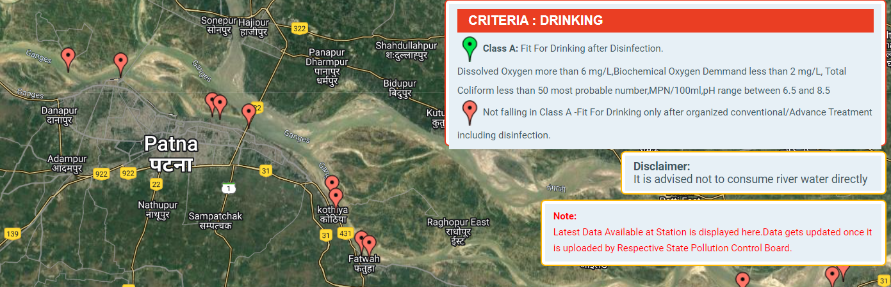

Fig. 11 Quality of water of River Ganga in Patna (CPCB, 2023)

According to renowned environmentalist RK Sinha, the total coliform count in Patna downstream was measured at 1,60,000 MPN/100ml against the permitted amount of only 2500 MPN/100m (Hindustan Times, 2015). Sinha was quoted saying, “The faecal coliform count is also alarmingly high at 50,000 MPN/100ml, about 100 times above the permissible. Let alone consumption, even bathing is dangerous.” About 250 to 300 MLD of waste water is pumped to the Ganga River from several locations, including sump houses owned by the PMC.

**Water source and consumption**

Patna relies on the Ganga, as well as groundwater, for drinking. However, less than 10% of the city's population has access to a sewage network, which means that 90% of the city's excreta is dumped into open sewers and ultimately into the Ganga. This sewage also percolates into the groundwater, which the PMC pumps up (CSE, 2012).

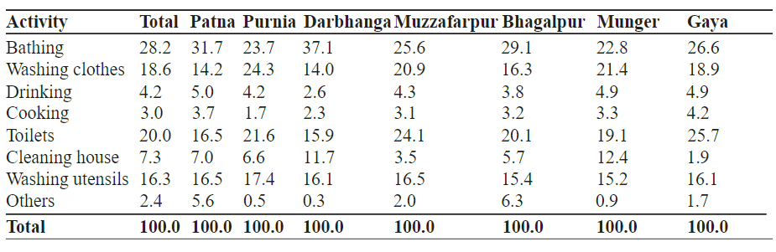

Fig. 12 Domestic activity-based consumption of water (in %) (Anand et al., 2023)

Overexploitation and unsuitable management of groundwater has resulted in a shortage of water in Bihar. Despite being situated on the banks of the Ganga, Patna's water needs are fully met by underground water sources. The water level in the Patna district varied from 0.54 m BGL to 8.92 m BGL during the pre-monsoon period (May 2020), and from 0.12 m BGL to 5.03 m BGL during the mid-monsoon (August 2020) (Aryan et al., 2023).

**Reduction of vegetation along river bank**

When comparing land characteristics between 2013 and 2019, it is clear that the number of water bodies has decreased by about 28%. The changes in question were evident due to the exposure of the river bed as the river meandered downstream, and were caused by an increase in the river bed, which became more visible in the downstream of the Ganga River in 2019. Another factor contributing to the decrease in water bodies is the drying up of urban water bodies, caused by unplanned urbanization. The urban area has grown by over 18.30%, from 81.67 km2 in 2013 to 97 km2 in 2019. This rise came at the expense of vegetation, which has declined by about 16.50% over the same period (Rashiq & Prakash, 2023).

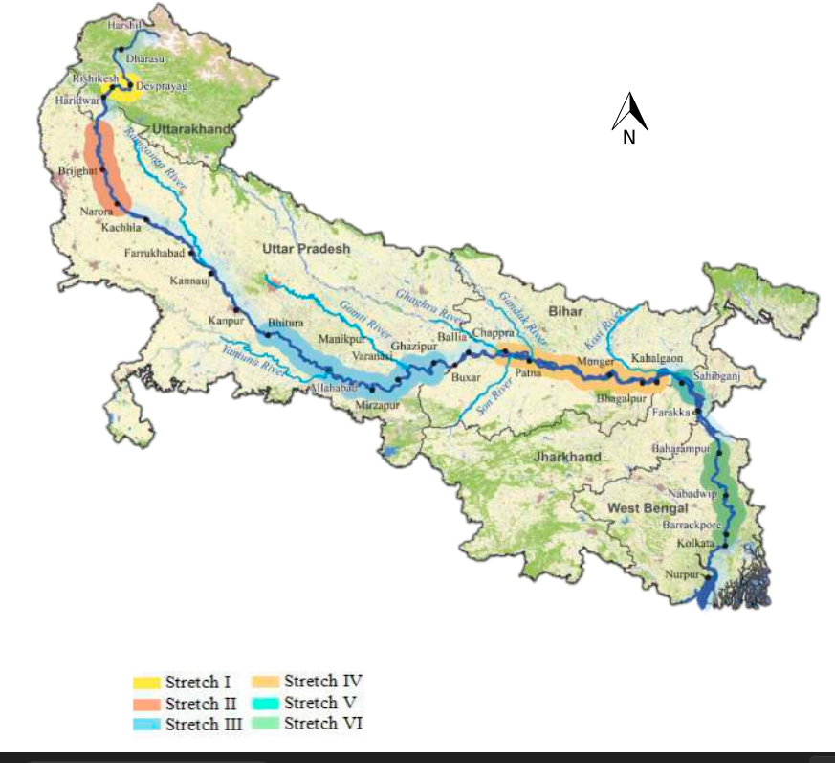

Fig. 13 Biodiversity along the Ganga basin

The amount of bare soil increased by around 6% between 2013 and 2019. Vegetation absorbs rainfall and reduces runoff by intercepting losses and storing water in plant roots, which improves infiltration. Reduced vegetation led in less infiltration and losses, eventually increasing runoff volume.

**Climate change**

Bihar is home to many homeless, disadvantaged, underprivileged, and vulnerable people. Weather-related catastrophes can cause grief and difficulty for both children and mothers. North Bihar also has floods every year, whilst south Bihar experiences droughts. Several prior research have shown that floods and droughts create physical, emotional, and psychological stress. Every year, North Bihar experiences an extreme disaster event that causes death, loss of a family member, home destruction, job loss, domestic animal death, crop damage, indirect malnutrition, and so on, whereas South Bihar experiences drought, which has led to an accumulation of mental health exposure among rural people.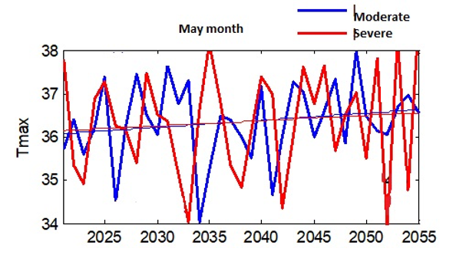

Fig 14. Projections on maximum temperature change (The Wire Science, 2020)

The cost of repairing flood-drought damage to a home or crop region is high. Non-good governance contributes significantly to mental illnesses such as anxiety, depression, and insomnia, whereas drought is always a risk factor for suicide in extreme cases. Farmer suicide is the result of these two terrible disasters. It erodes vulnerable people's socioeconomic conditions and has the potential to deplete the state treasury. It fosters employment and migration. It may also result in a more aggressive future society.

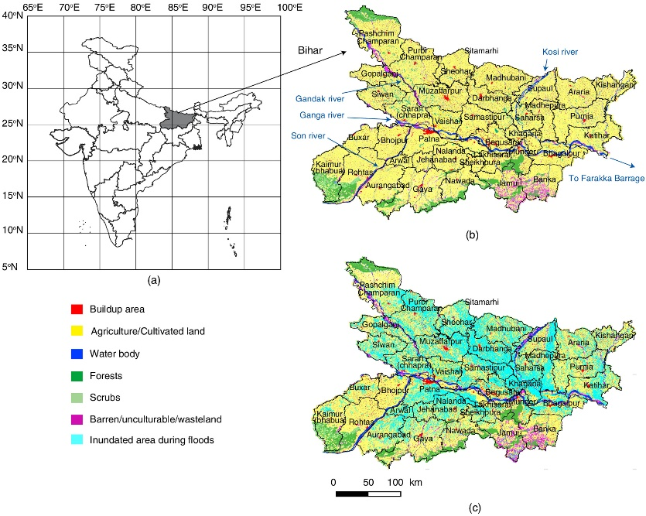

Fig. 15 Study area: (a) state of Bihar on India map; (b) land-use pattern in Bihar; and (c) extent of damage due to floods in Bihar, shown as the cumulate area that has been inundated in the period 2001–2010 in Bihar. (Map data from the India Geo-Platform, Bhuvan, National Remote Sensing Centre, ISRO, Government of India, Hyderabad, India.) (Kouser-Asif, 2021)

During the 2019 Patna floods, Tarun Gopalakrishnan, a climate policy researcher at the Centre for Science and Environment, commented that “climate change is resulting in more erratic rainfall patterns, including a large portion of seasonal rainfall being concentrated in a limited number of days, leading to flooding. Limiting the human cost of this trend will require drastically cutting carbon emissions around the globe, while investing in adaptation for the new climate reality.” (Firstpost, 2019)

**DATASET**

For this research, the area chosen concentrates on the urban area along a 25-kilometer stretch of the Ganga River in Patna, as highlighted in the image sourced from Google Earth. This stretch encompasses a densely populated riverside region that exhibits significant urban development.

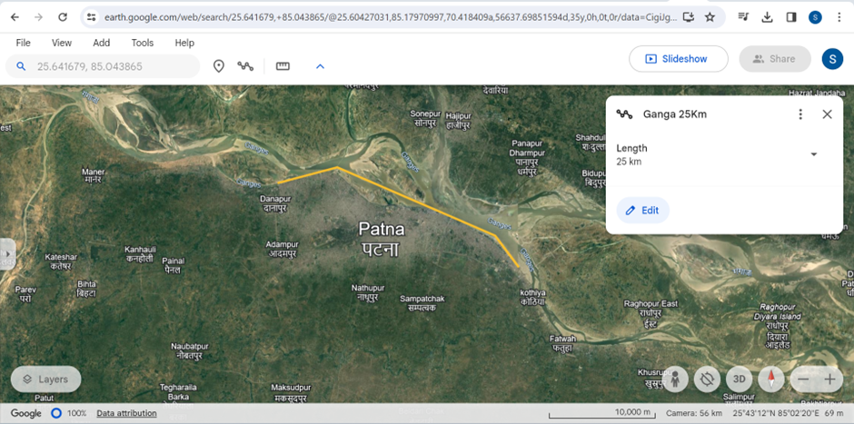

Fig. 14 Length of the Ganga in Patna (Google Earth, 2024)

Through satellite imagery obtained from Google Maps, a bustling urban landscape has been along the riverbank. This area is characterized by a diverse array of structures, including residential buildings, commercial establishments, shops, schools, highways and more.

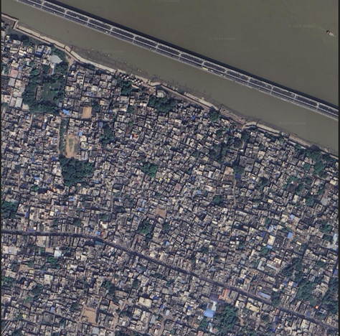 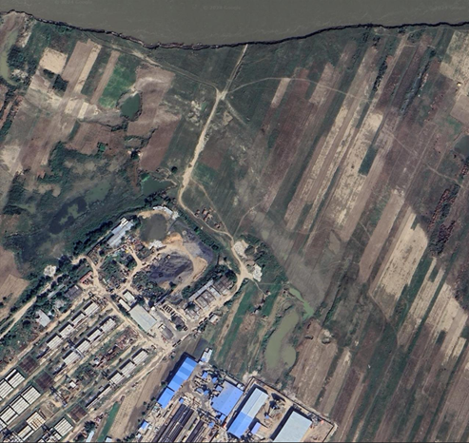

Fig. 15 Satellite images of Patna along River Ganga (Google Maps, 2024)

Notably, the architecture of the houses along the riverbank lacks uniformity, reflecting a mix of construction styles and sizes. Additionally, the surroundings feature a blend of agricultural fields and industrial facilities, contributing to the dynamic nature of the landscape.

In our research methodology, we gather data from Google Maps in satellite terrain format using specified latitude, longitude, and zoom parameters. We specifically exclude any labels or textual information, focusing solely on the visual elements of the satellite imagery.

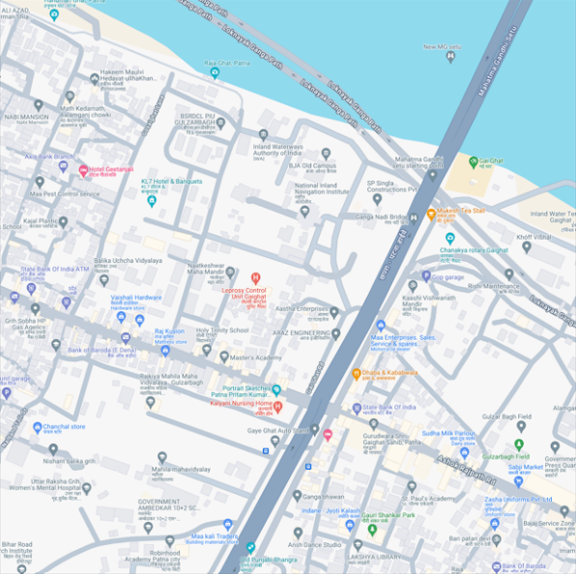 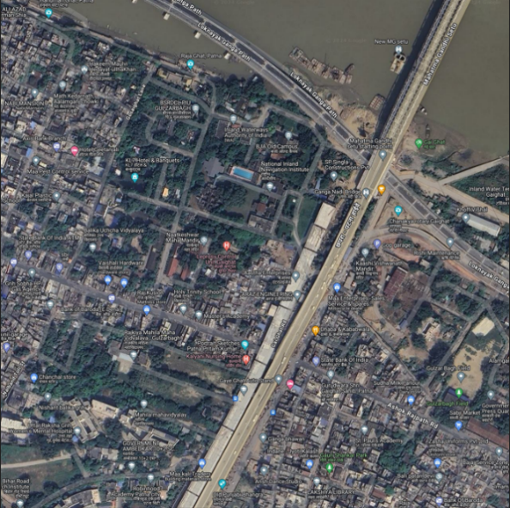

1. Default terrain image (ii) Satellite terrain image (with labels)

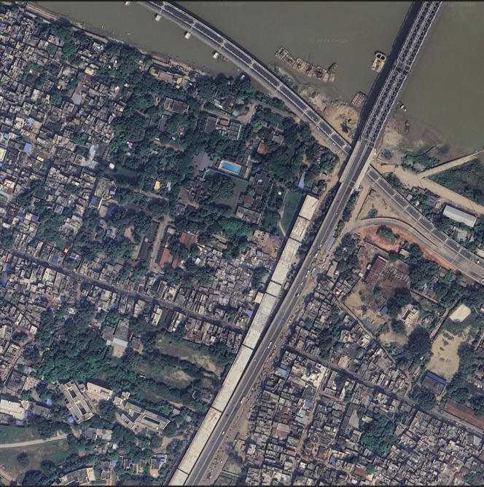

(iii) Satellite terrain image (without labels)

Fig. 16 Default and satellite terrain images (Google Maps, 2024)

The primary objective of our study is to leverage this dataset to estimate the number of people affected by potential flooding of the Ganga River using computer vision techniques. We plan to achieve this by utilizing the satellite images to count the number of houses alongside the Ganga River. Assuming an average occupancy of six people per house, we aim to estimate the total number of individuals affected by flooding events. This analysis will provide valuable insights into the potential impact of Ganga flooding on urban populations in the Patna region. Through our research, we seek to enhance disaster preparedness and mitigation strategies in the area, thereby aiding in the development of more effective response plans.

**METHOD**

**Edge detection**

**Canny edge detection**

Canny edge detection is a common image processing technique utilized extensively in various applications. It operates as an unsupervised learning algorithm, aimed at identifying edges within images- a critical step in tasks such as object detection and image segmentation. In the context of identifying houses by counting the number of rooftops present in an image, Canny edge detection plays a pivotal role in delineating the boundaries of objects, particularly rooftops, against the background (Li, Ding, 2011; Canny, 1986).

Our code transforms the image for rooftop detection. First, it is transformed to the HSV colour space, enabling more accurate colour segmentation. A mask is then generated to isolate rooftop zones based on predetermined colour ranges. Following that, Canny edge detection is used to locate possible rooftop edges. The identified rooftop contours are then improved and counted before being shown on the original image. This extensive pipeline seamlessly incorporates many phases for effective rooftop detection in satellite data.

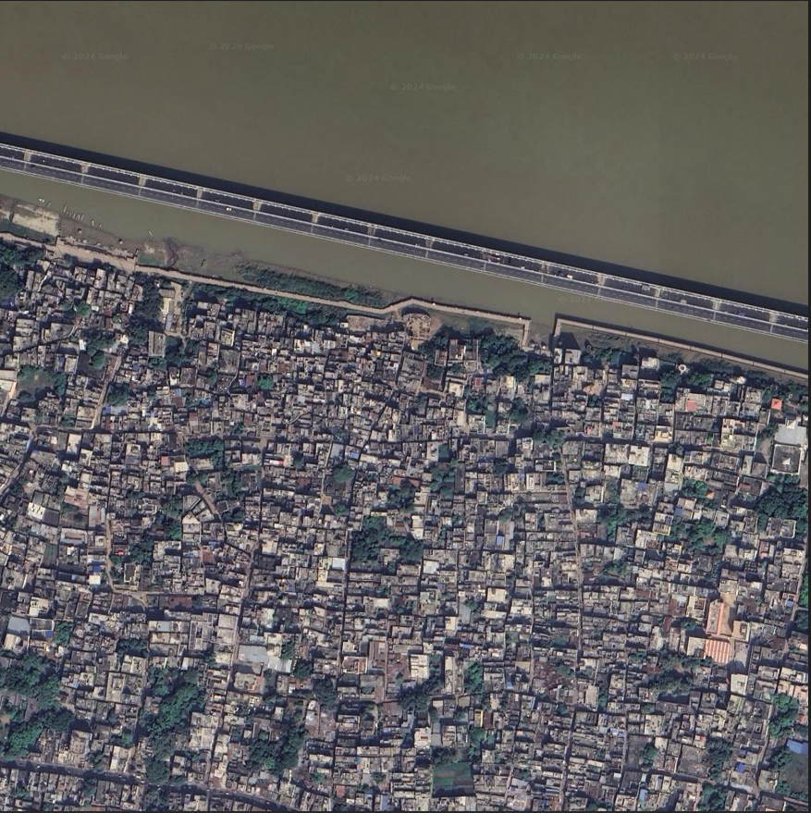 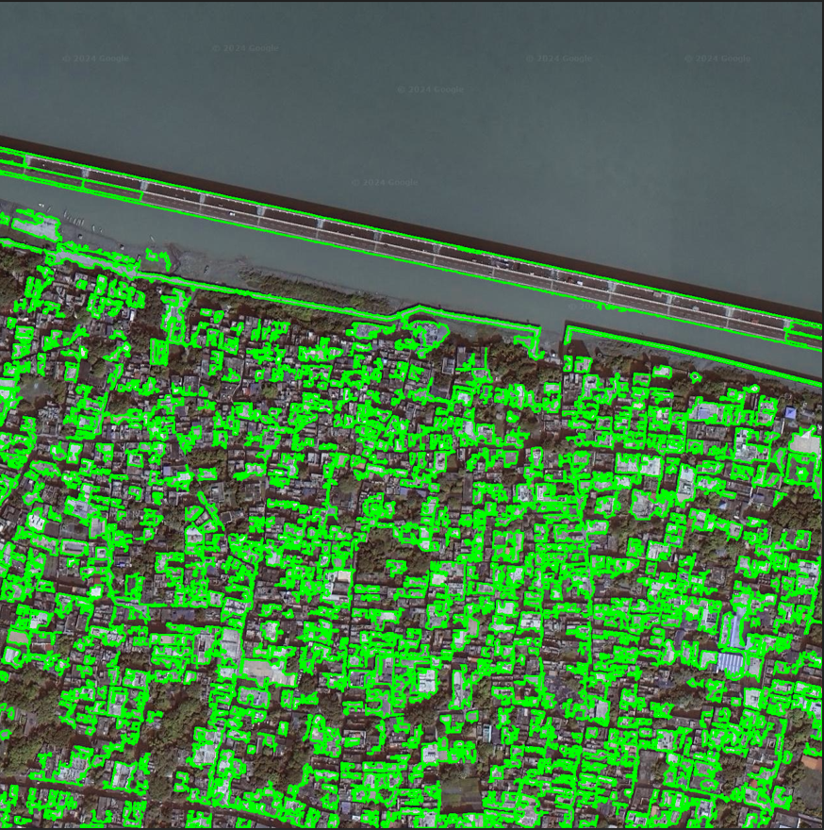



(i) Code successfully counts 538 rooftops out of ~700 rooftops

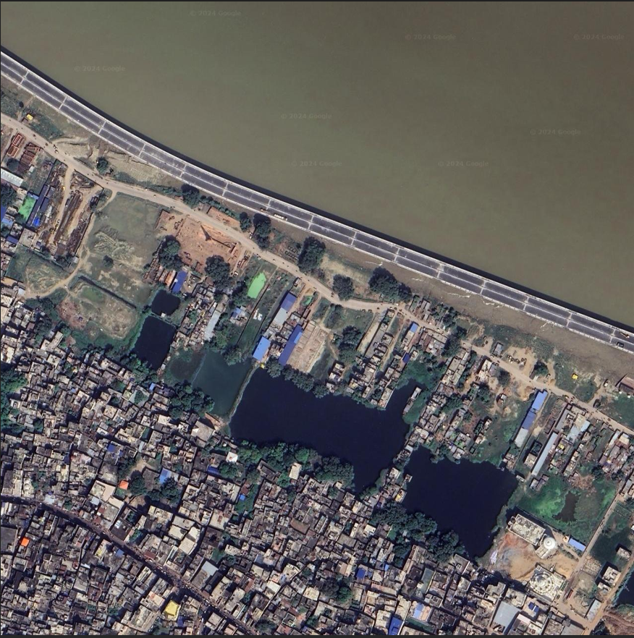 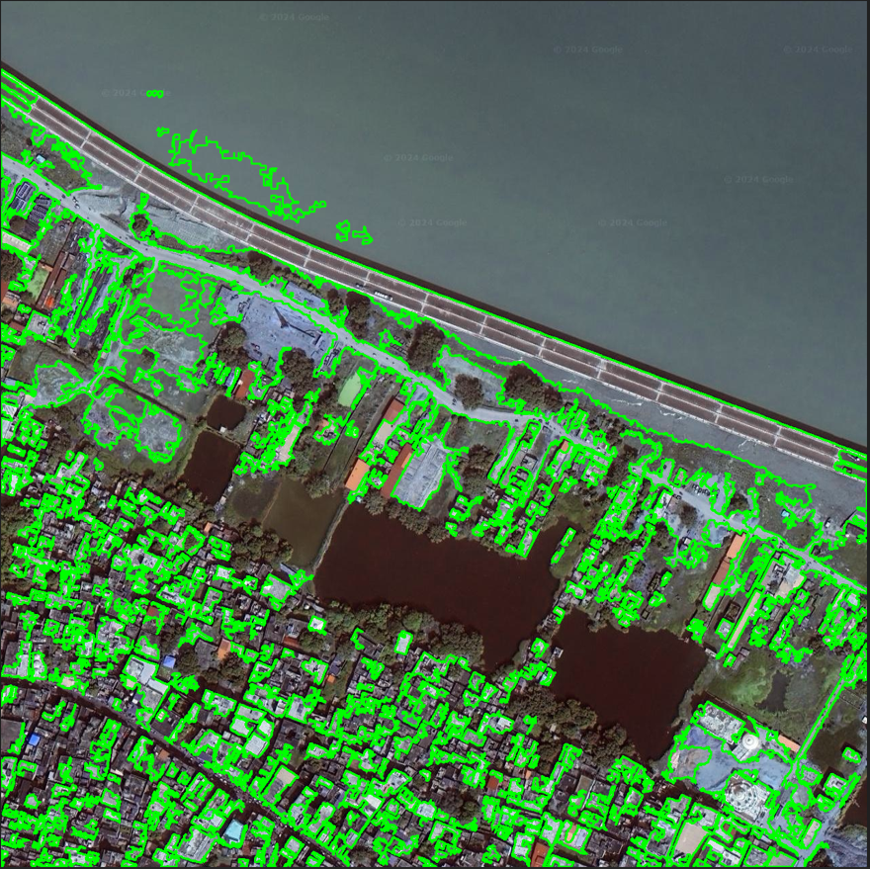



(ii) Code successfully counts 309 rooftops out of ~350 rooftops

Fig. 17 Original image versus Canny edge detection generated image

The Canny edge detection model effectively identifies a majority of rooftops in the input images, while successfully excluding trees, water bodies, and roads. Although it can capture linear features like building edges or bridges, to some degree, our method has been fine-tuned to prioritize rooftop detection. However, it occasionally overlooks houses with very small boundaries, failing to classify them accurately.

By integrating Canny edge detection into this pipeline, the proposed approach presents a reliable and efficient solution for rooftop detection in satellite imagery, showcasing its potential in various real-world applications such as urban planning, infrastructure management, and environmental surveillance.

**Sobel edge detection**

Sobel edge detection is an unsupervised, popular approach for detecting edges or boundaries in images. It belongs to a class of convolutional filters that highlight intensity variations in opposite directions. The Sobel operator highlights vertical or horizontal borders in an image.

The Sobel operator employs a pair of 3x3 convolution kernels, one for detecting changes in intensity in the horizontal direction, and another for the vertical direction. The convolution operation involves sliding these kernels over the image, and at each position, computing the weighted sum of the pixel values in the neighbourhood defined by the kernel. The result of the convolution at each pixel represents the gradient magnitude in the corresponding direction.

After applying the Sobel operator separately in the horizontal and vertical directions, the magnitude of the gradient at each pixel can be computed using the following formula:

$$gradient magnitude= \sqrt{{(horizontal gradient)}^{2}+ {(vertical gradient)}^{2}}$$

While the direction of the edge is determined by the formula:

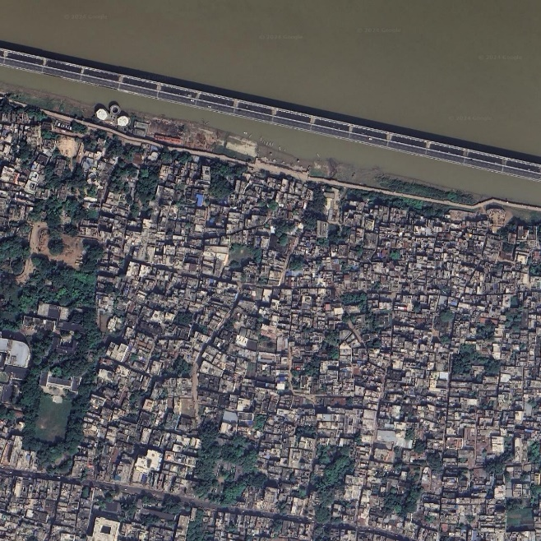 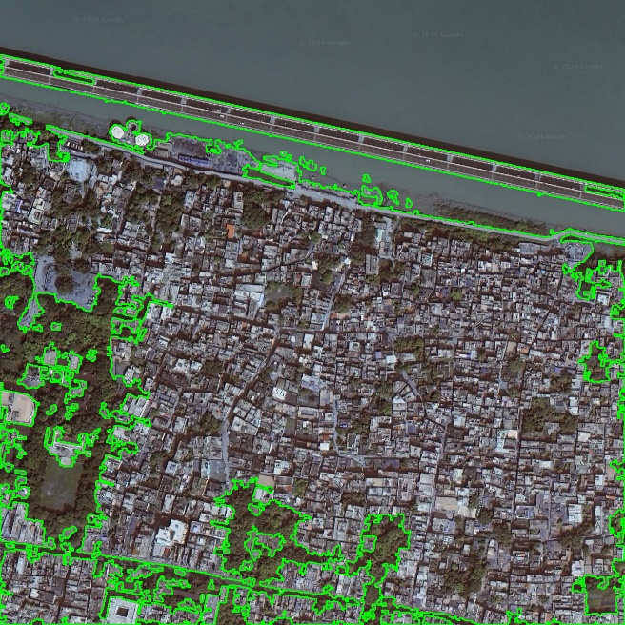



(i) Code successfully counts 53 rooftops out of ~700 rooftops

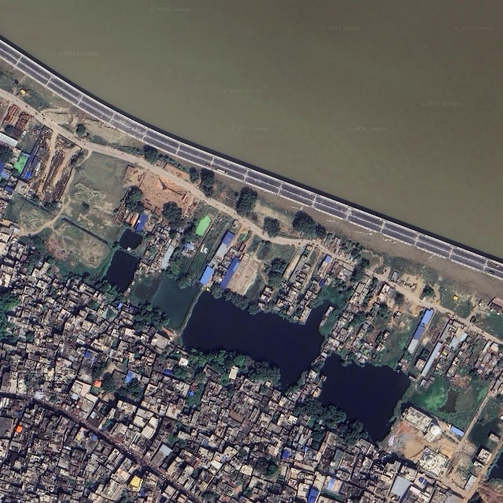 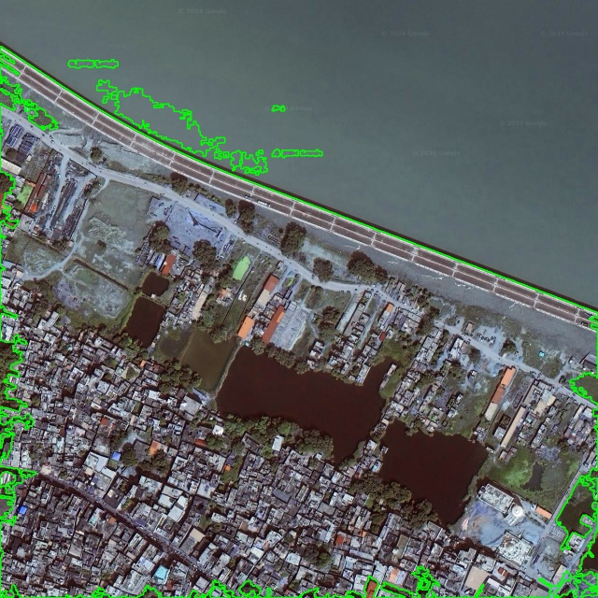



(ii) Code successfully counts 22 rooftops out of ~350 rooftops

Fig. 18 Original image versus Sobel edge detection generated image

Sobel edge detection can be used as a preprocessing step for image segmentation. The edges detected by the Sobel operator often correspond to boundaries between different objects or regions in an image. As seen in fig. 17, the Sobel function counts and detects clusters of trees, instead of individual rooftops, when applied to the dataset. Thus, it was not chosen to be the final model for calculating the number of houses in the Ganga floodplain.

**Laplacian edge detection**

Laplacian edge detection is another unsupervised image processing approach that detects edges in images. The Laplacian operator calculates an image's second spatial derivative, focusing on regions with rapid intensity variations. It is especially useful for highlighting small details and edges.

The Laplacian is often applied to a 3x3 kernel, and applied to the image using convolution. The resulting image represents the magnitude of the second derivative of intensity with respect to spatial coordinates.

Mathematically, the convolution operation for a pixel *(i, j)* in the Laplacian-transformed image *L* can be expressed as:

$$L\left(i, j\right)= \sum_{m=-1}^{1}{\sum_{n=-1}^{1}{K\left(m, n\right)∙I\left(i+m, j+n\right)}}$$

where,

*L*(*i*,*j*) is the value of the Laplacian-transformed image at position (*i*, *j*),

*K*(*m*, *n*) is the Laplacian kernel element at position (*m*, *n*), and

*I*(*i*+*m*, *j*+*n*) is the intensity value of the original image at position (*i*+*m*, *j*+*n*).

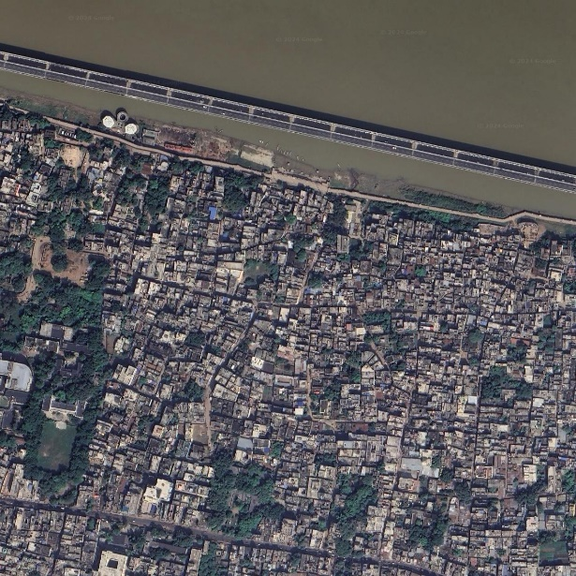 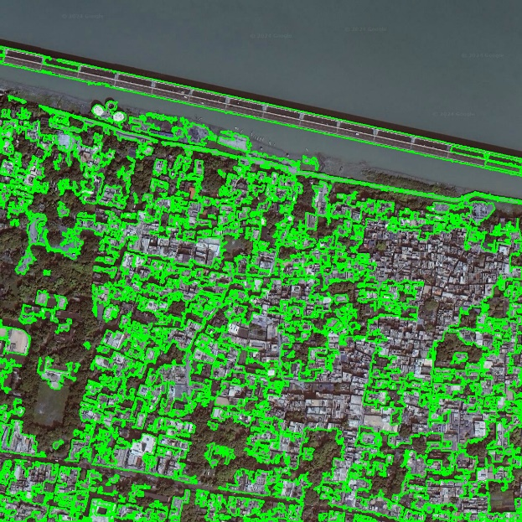



(i) Code successfully counts 187 rooftops out of ~700 rooftops

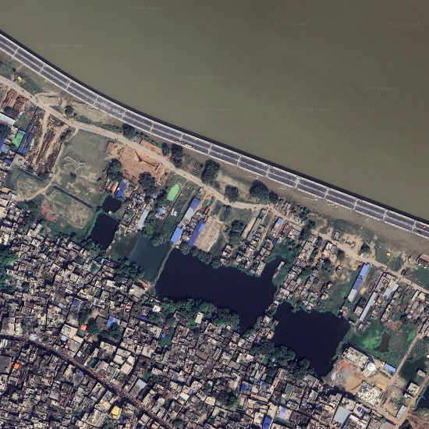 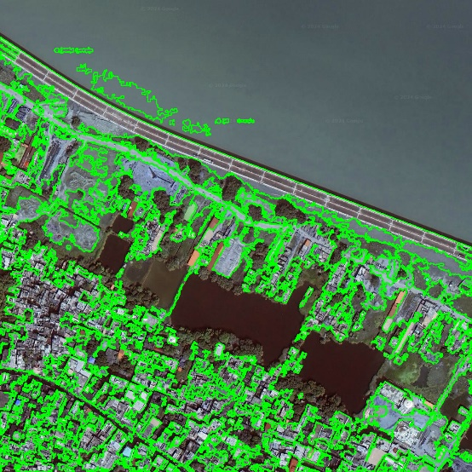



(ii) Code successfully counts 130 rooftops out of ~350 rooftops

Fig. 19 Original image versus Laplacian edge detection generated image

The Laplacian operator improves regions where intensity fluctuates rapidly, which frequently correlate to image edges. However, it is noise-sensitive, and thus is unable to differentiate the houses from each other when applied to the dataset.

**Other methods**

**Connected component labelling**

Connected component labelling involves creating an image where pixels belonging to the same connected component in a binary image receive a unique label, distinguishing them from pixels in other components. This process enables segmentation and analysis of distinct objects or regions within the image.

The code utilizes a rooftop detection method that involves several steps: conversion of the image to HSV colour space, creation of a mask using predefined colour ranges to isolate rooftops, thresholding and connected component labelling to identify rooftop areas, and drawing bounding boxes around the detected rooftops for visualization and counting. This approach efficiently segments and identifies rooftop structures in high-resolution satellite images sourced from Google Maps.

 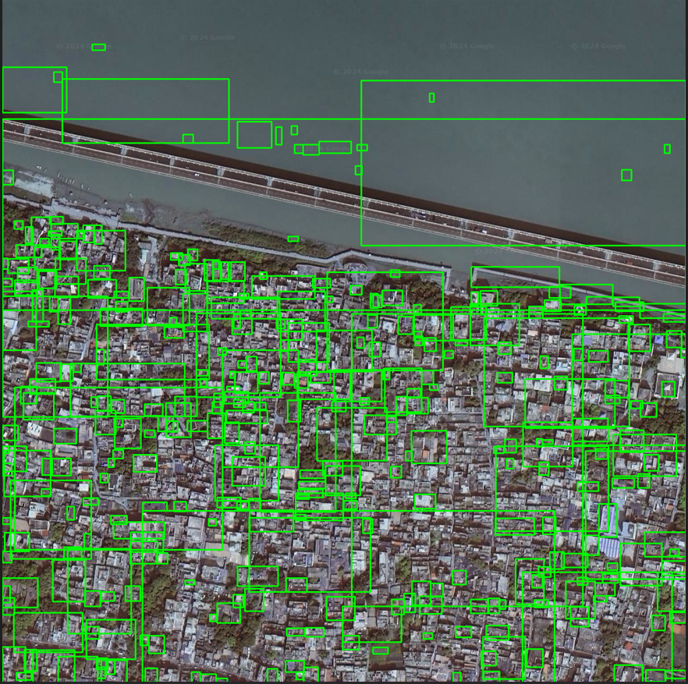



(i) Code successfully counts 358 rooftops out of ~700 rooftops

 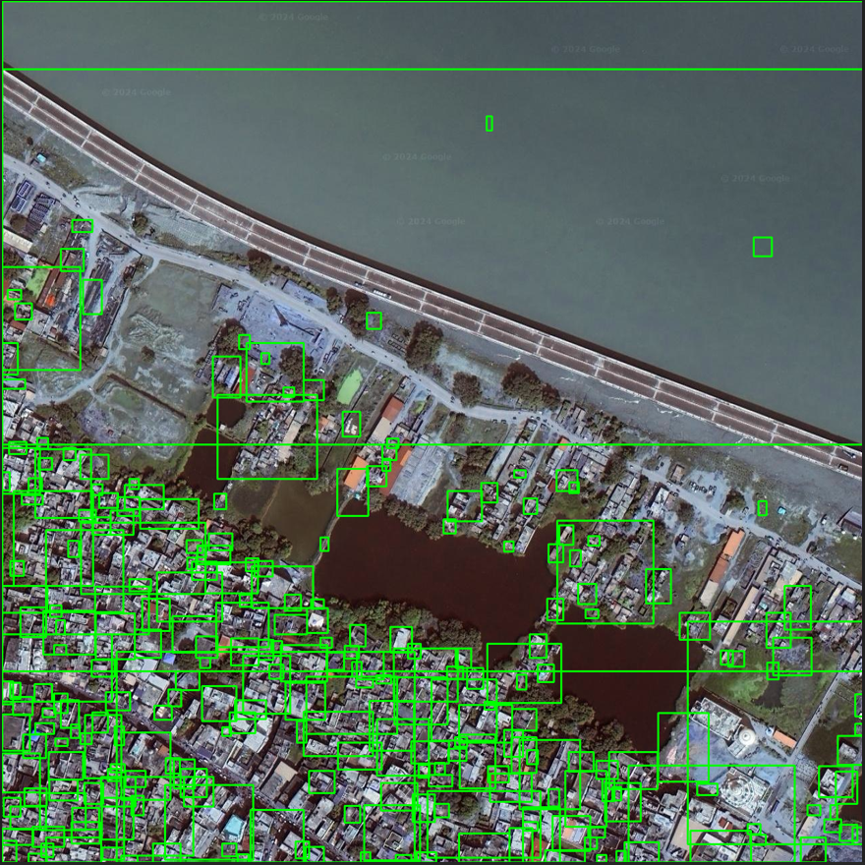



(ii) Code successfully counts 268 rooftops out of ~350 rooftops

Fig. 20 Original image versus Connected Component Labelling generated image

While this approach does identify houses, its performance is not as robust as Canny edge detection on our dataset. It struggles to distinguish small houses individually, often grouping them together and counting them as a single entity. Additionally, it mistakenly identifies certain objects such as boats on water bodies as rooftops, leading to inaccuracies in the detection process.

**Mean shift segmentation**

Mean shift is an unsupervised clustering approach (Fukunaga & Hostetler in Kaftan, Bell & Aach, p. 365) that detects modes by iteratively estimating the gradient of a probability density function. As a result, applying this technique to the combined spatial-range domain yields image segmentations that consider colour/intensity similarity as well as local connection. Mean shift segmentation has been used successfully in a variety of applications (Comaniciu & Meer, Suri et al., 2002; Bell et al., 2006 in Kaftan, Bell, and Aach, p. 365).

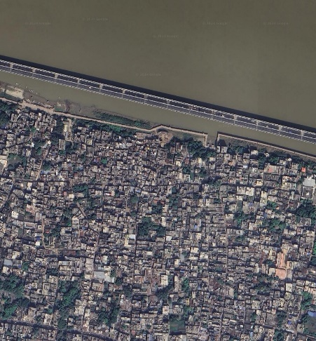 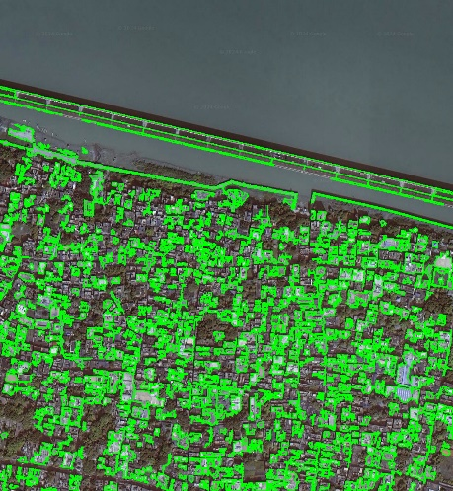 

(i) Code successfully counts 520 rooftops out of ~700 rooftops

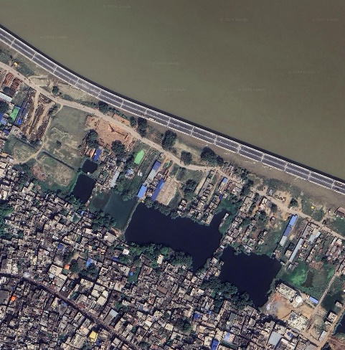 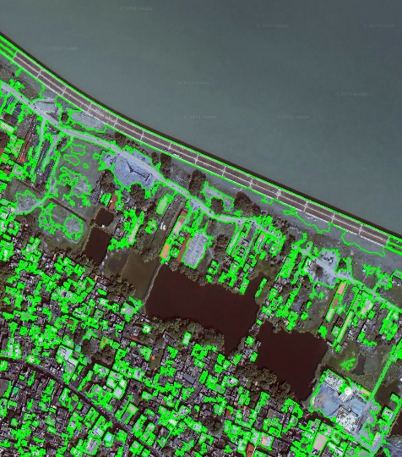



(ii) Code successfully counts 300 rooftops out of ~350 rooftops

Fig. 21 Original image versus Mean Shift generated image

Our code uses a rooftop count function for evaluating high-resolution satellite imagery, with a focus on finding rooftop structures. Following segmentation, the program transforms the segmented image to grayscale and uses thresholding to generate a binary mask that highlights prospective rooftop locations while reducing background noise. The contours that represent the boundaries of these areas are then retrieved using contour detection algorithms. The method then filters these contours by area, removing smaller contours that are unlikely to match to rooftops. Finally, the function outlines the detected rooftops by painting contours on the original image and provides the number of recognized rooftops, allowing for more efficient detection and quantification of rooftops inside satellite images using computer vision algorithms.

**ABBREVIATIONS**

BGL – Below Ground Level

MLD – Million Liters per Day

MPN – Most Probable Number

PMC – Patna Municipal Corporation

**REFERENCES**

<https://tourism.bihar.gov.in/en/destinations/patna>

C. M. Bhatt, Amitesh Gupta, Arijit Roy, Prohelika Dalal & Prakash Chauhan (2021) Geospatial analysis of September, 2019 floods in the lower gangetic plains of Bihar using multi-temporal satellites and river gauge data, Geomatics, Natural Hazards and Risk, 12:1, 84-102, DOI: 10.1080/19475705.2020.1861113

https://censusindia.gov.in/census.website/data/population-finder

Diwakar, Sumant & Kaur, Surinder & Das, Ashok & Nagarkoti, Jyoti. (2016). Performance of WRF (ARW) over River Basins under Flood Met Office, Patna during Flood Season 2014. 10.13140/RG.2.1.1155.9286.

<http://gfcc.gov.in/sites/default/files/Annual%20Report%202021-22.pdf>

https://www.floodmap.net/?gi=1260086

<https://timesofindia.indiatimes.com/city/patna/work-on-construction-of-185-km-drainage-network-begins-in-patna/articleshow/98788725.cms>

<https://timesofindia.indiatimes.com/city/patna/no-new-drainage-system-built-in-city-in-51-yrs-min/articleshow/71400503.cms>

http://cdn.cseindia.org/userfiles/patna.pdf

<https://www.mdpi.com/2673-4591/56/1/85>

<https://www.hindustantimes.com/patna/river-ganga-most-polluted-along-patna-stretch/story-g7Plb9W3RB6KGTBloUB05M.html>

<http://ewqdes.cpcb.gov.in/wqi/>

<https://cpcb.nic.in/ngrba/index.php>

<https://www.cseindia.org/patna-drinks-its-own-sewage-4215>

Anand, Rashmi & Rajput, Swati & Sanu, Shubham & Sinha, Pratyush. (2023). Assessing Availability and Consumption of Water Resource Dynamics in Selected Districts of Bihar, India. International Journal of Ecology and Environmental Sciences. 49. 71-81. 10.55863/ijees.2023.2554.

Aryan, Y., Thambidurai, P., Dikshit, A.K. (2023). Suitability of Groundwater for Drinking and Agricultural Use in Patna District, Bihar, India. In: Thambidurai, P., Dikshit, A.K. (eds) Impacts of Urbanization on Hydrological Systems in India. Springer, Cham. <https://doi.org/10.1007/978-3-031-21618-3_12>

<https://ffs.india-water.gov.in/#/>

Rashiq, A., Prakash, O. (2023). Urban Floods: A Case Study of Patna Floods 2019 – Natural or Anthropogenic?. In: Thambidurai, P., Dikshit, A.K. (eds) Impacts of Urbanization on Hydrological Systems in India. Springer, Cham. <https://doi.org/10.1007/978-3-031-21618-3_4>

<https://nmcg.nic.in/pdf/Ganga%20Biodiversity%20at%20a%20Glance.pdf>

<https://earth.google.com/web/@25.61699073,85.19231989,79.37692216a,1927.39019895d,35y,7.69756536h,0t,0r/data=OgMKATA>

<https://www.google.com/maps/@25.6156025,85.1723576,9250m/data=!3m1!1e3?entry=ttu>

<https://www.frontiersin.org/articles/10.3389/frai.2020.534696/full>

<https://www.researchgate.net/profile/Dr-Tasneem-Ahmed/publication/356398565_Monitoring_and_Mapping_of_Flash_Flood_of_Patna_City_Using_Sentinel-1_Images_A_Case_of_India's_Most_Flood_Prone_State/links/619a685b07be5f31b7a6cb6d/Monitoring-and-Mapping-of-Flash-Flood-of-Patna-City-Using-Sentinel-1-Images-A-Case-of-Indias-Most-Flood-Prone-State.pdf>

<https://science.thewire.in/environment/bihar-climate-change-agriculture/>

<https://www.firstpost.com/tech/science/bihar-floods-experts-blame-climate-change-global-warming-unplanned-development-for-rains-7444171.html>

<https://doi.org/10.1061/(ASCE)NH.1527-6996.0000527>

Li, J., Ding, S. (2011). A Research on Improved Canny Edge Detection Algorithm. In: Zhang, J. (eds) Applied Informatics and Communication. ICAIC 2011. Communications in Computer and Information Science, vol 228. Springer, Berlin, Heidelberg. https://doi.org/10.1007/978-3-642-23223-7_13

J. Canny, "A computational approach to edge detection," IEEE Transactions on Pattern Analysis and Machine Intelligence, vol.8,no.6 pp.679-698, 1986.

Kaftan, JN, Bell, AA & Aach, T 2008, ‘Mean shift segmentation evaluation of optimization techniques’*, in proceedings of the Third International Conference on Computer Vision Theory and Applications*, VISAPP 2008.